Core16 LED Placement V0.2 (2023-09-19)

SK6812Mini-E LEDs are installed on the Back Side (AKA The Dark Side)

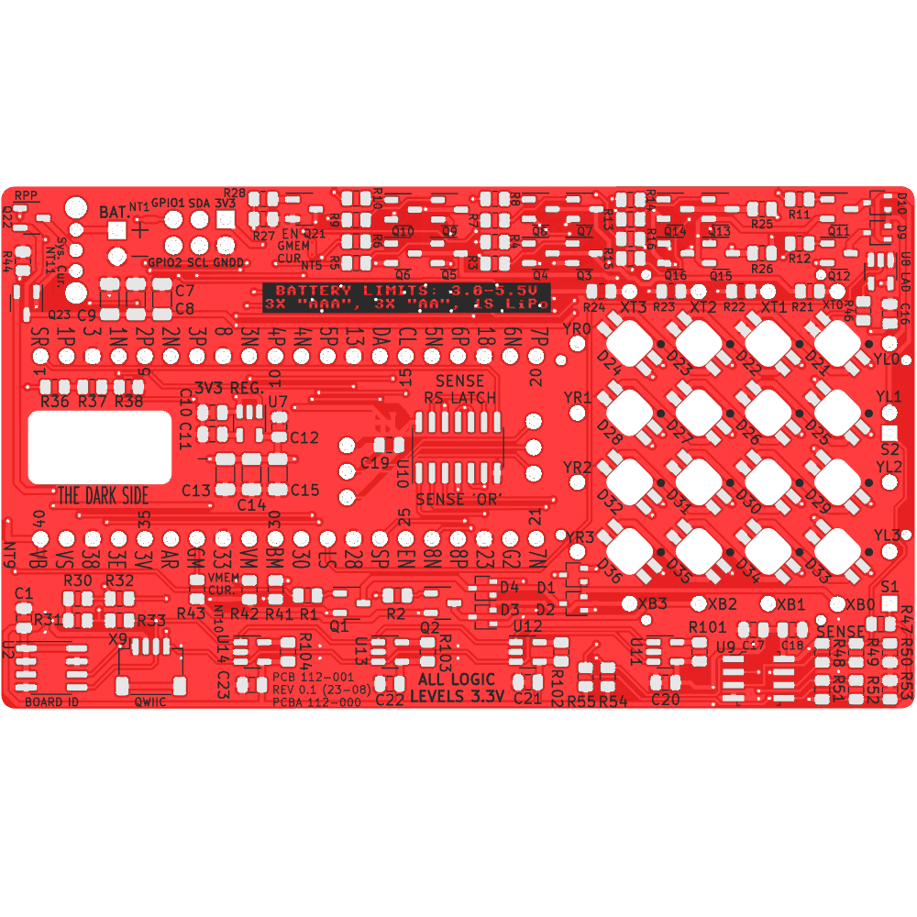

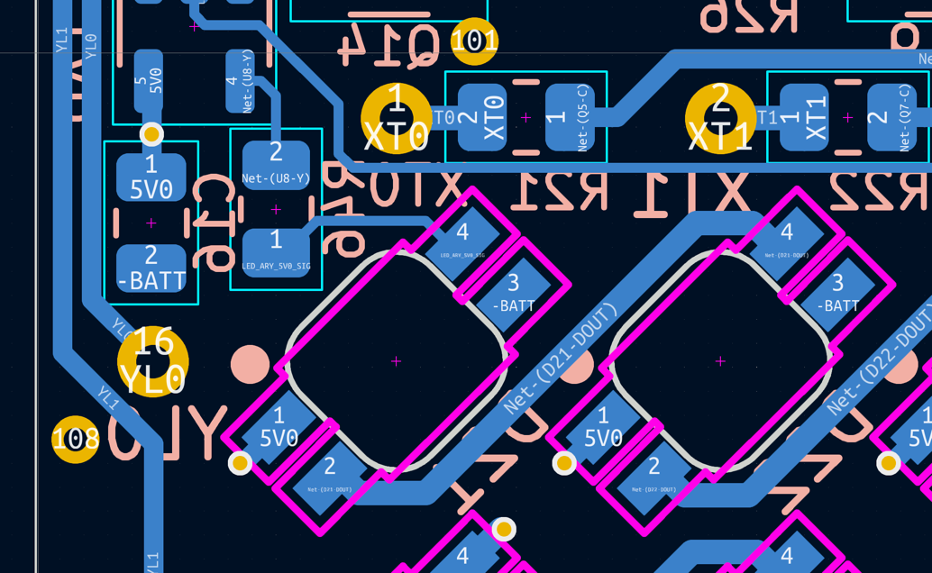

DOUT

DIN

5V0

GND

**CENTERED IN THE CUTOUT**

These LEDs are serially connected which means if any LED in the chain is missing or damaged, all the LEDs downstream will not work. When testing the assembly process, always start with D21.

For reference, this is how they look on the Front Side (AKA The Light Side)

